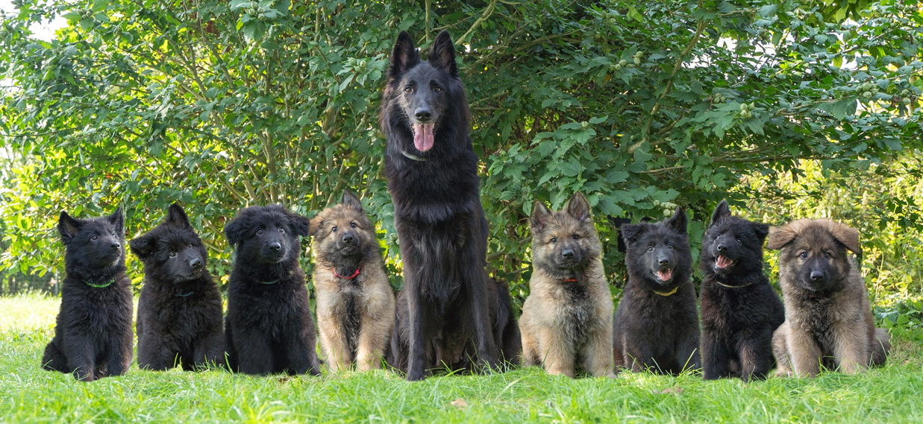

*Puppy buyer questionnaire*

Name:   
Address:   
Postal code:  
City:  
Country:  
E-mail:   
Phone number:

* How did you come by my kennel?
* Why are you interested in this outcross/cross?
* What are you looking for in a dog?
* Do you prefer a female or a male?
* Are you planning on breeding with the dog in the future?
* Would you be willing to keep in touch about the dog's progress?
* Where do you live(flat, apartment, farm)?
* Do you have a garden? If so, how many m2?
* How many hours per week are you at work?
* Who will take care of the dog while you are at work?
* What is the maximum amount of time the dog will be alone per day?
* Where will the dog live and sleep? (outside, inside, kennel)
* What do you want to do with the dog? (tracking, detection, agility)
* Do you have children? If so, how many and what is there age?
* Do you have a partner? If so, how many hours per week does he/she work?
* Do you have other pets? If so, what kind of pets?
* Do you have experience with the breeds from this outcross/cross?
* Do you have more dogs? If so, what breed, gender and age?
* Have you owned dogs in the past? If so, what breeds and why do you no longer have them?
* Are you willing to return the dog to me if you can no longer take care of it?
* Are you willing to visit me a few times to get to know me, the mother dog and the puppies?(This only applies to people who live in the Netherlands, Belgium, Germany or France. Of course your are still welcome to come and visit us if you live further away)
* Are you willing to come to a nest reunion?
* Do you have any questions for me?

Send this document with your answers to: info@debleekvelden.nl